**Steps for Creating a Package using MSIX Packaging Tool**

**Steps:**

1. Download **MSIX Packaging Tool** from Microsoft Store
2. Open MSIX Packaging Tool and in **Select Task** select **Application Package**

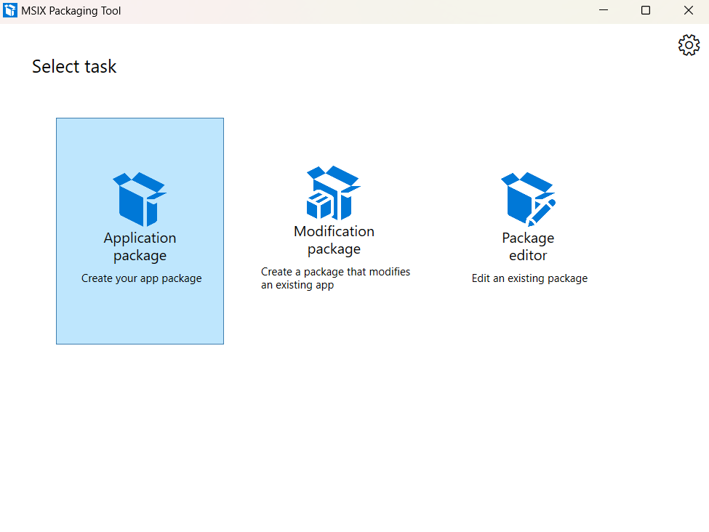

1. In **Select environment** tab, select first radio button **Create package on this computer** and click **Next**

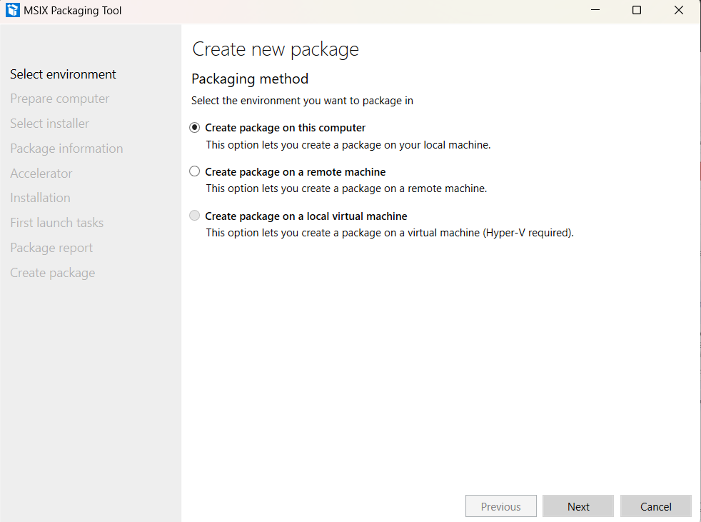

4)In **Prepare computer** tab, after the status shows **Installed**, at the bottom click on checkbox **Windows Search is active** and click **Next**

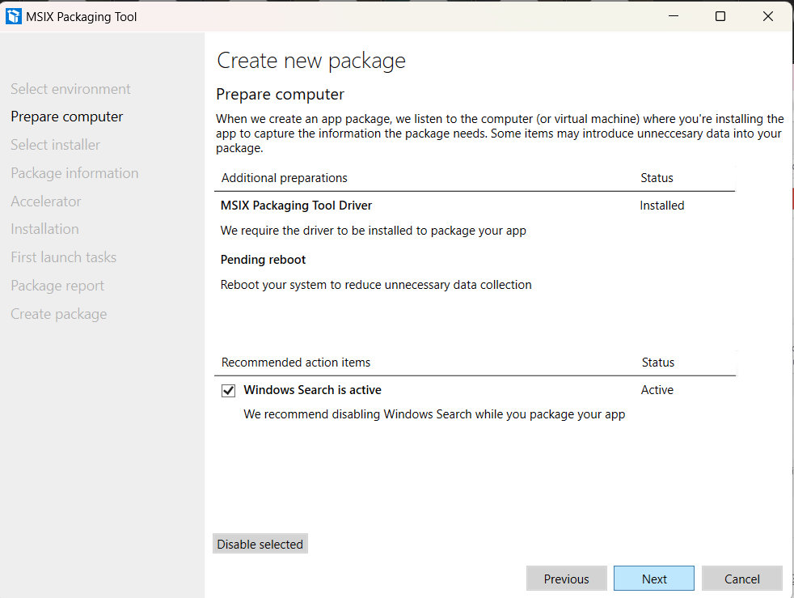

5)In **Select installer** tab, browse our .msi file (Firefox Setup 139.0.1.msi) and in **Signing preference** dialog box select **Do not sign package** and click **Next**

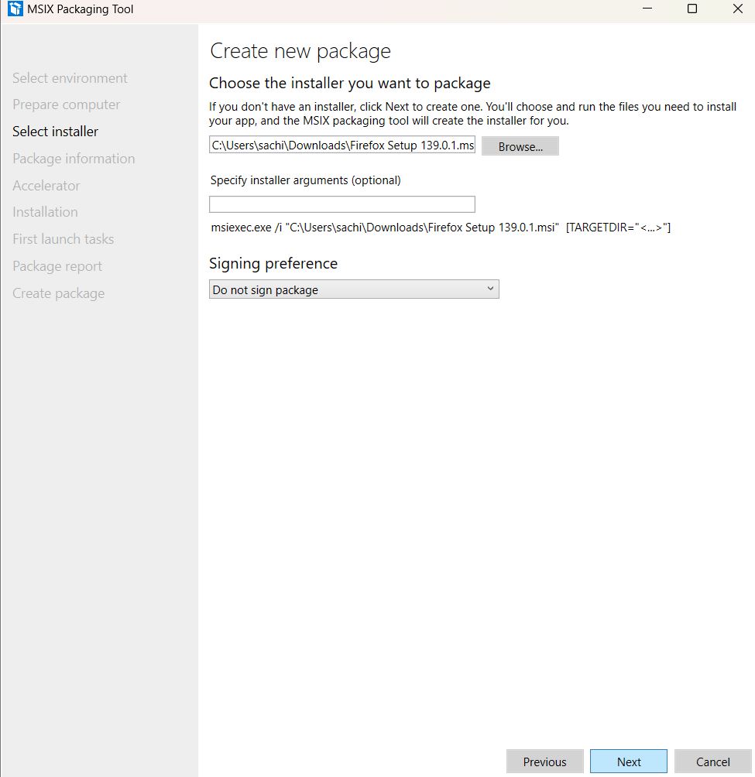

6)In **Package information** tab, in the **Publisher name** textbox write **CN=M** and click **Next**

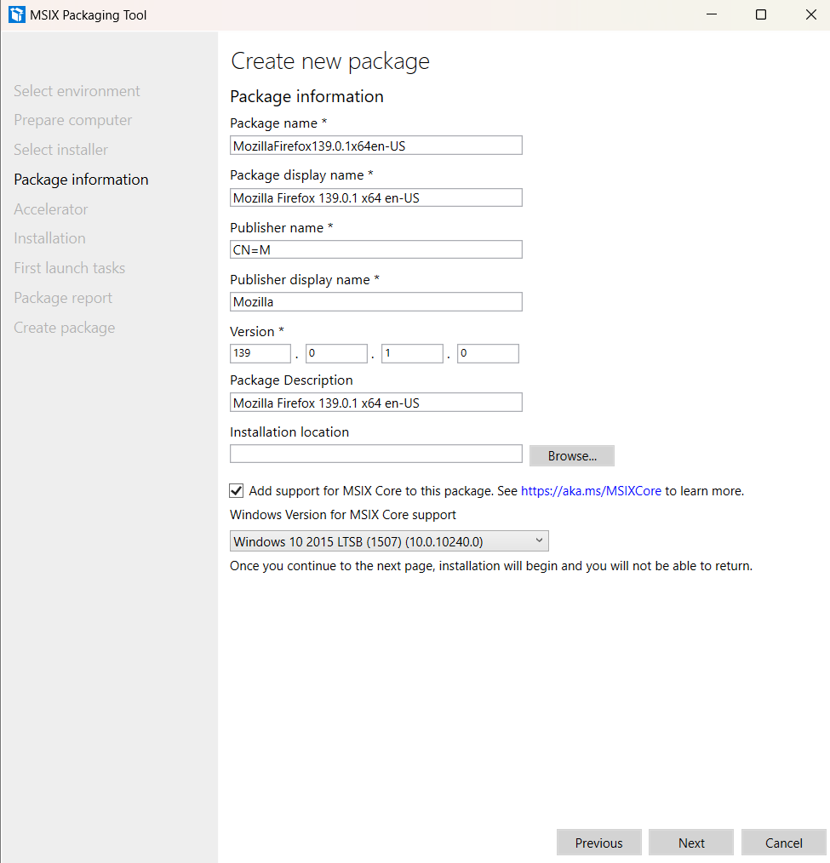

7)In **Accelerator** tab, do nothing and click **Next**

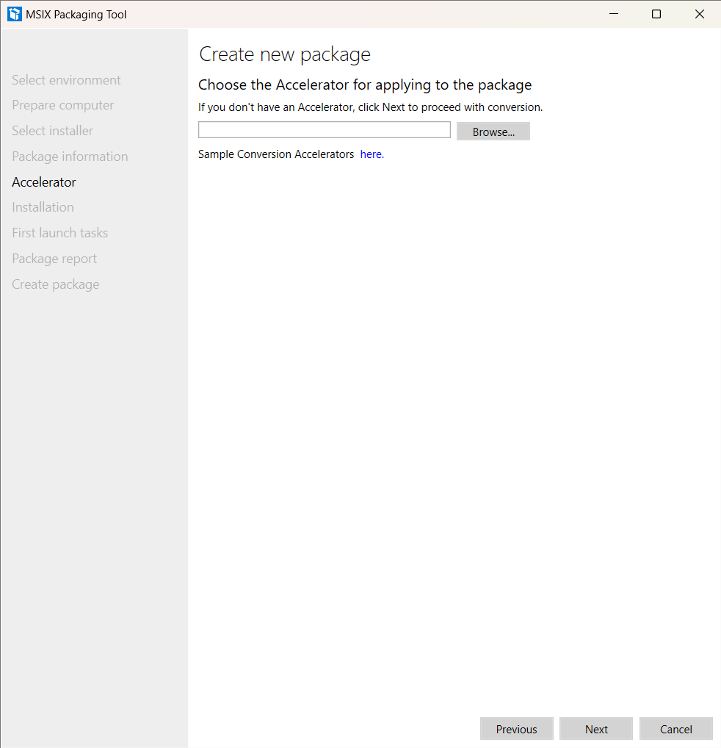

8)In **Installation** tab, do nothing and click **Next**

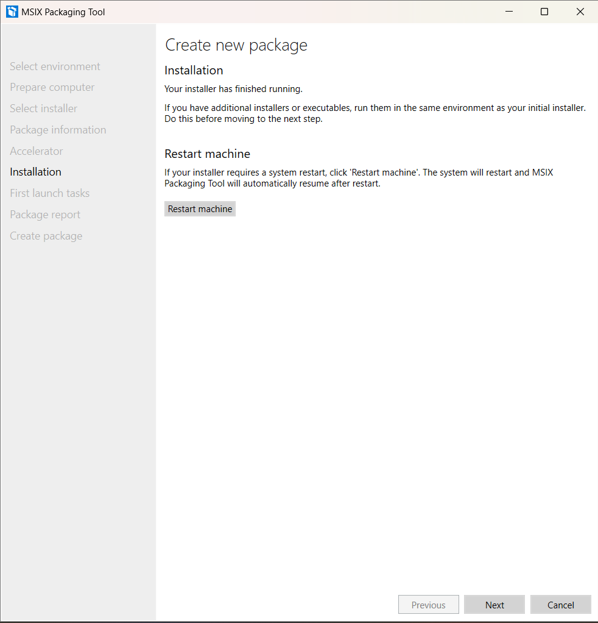

9)In **First launch tasks** tab, do nothing and click **Next** and then a small popup comes asking **Are you done?** so click **Yes, move on** button

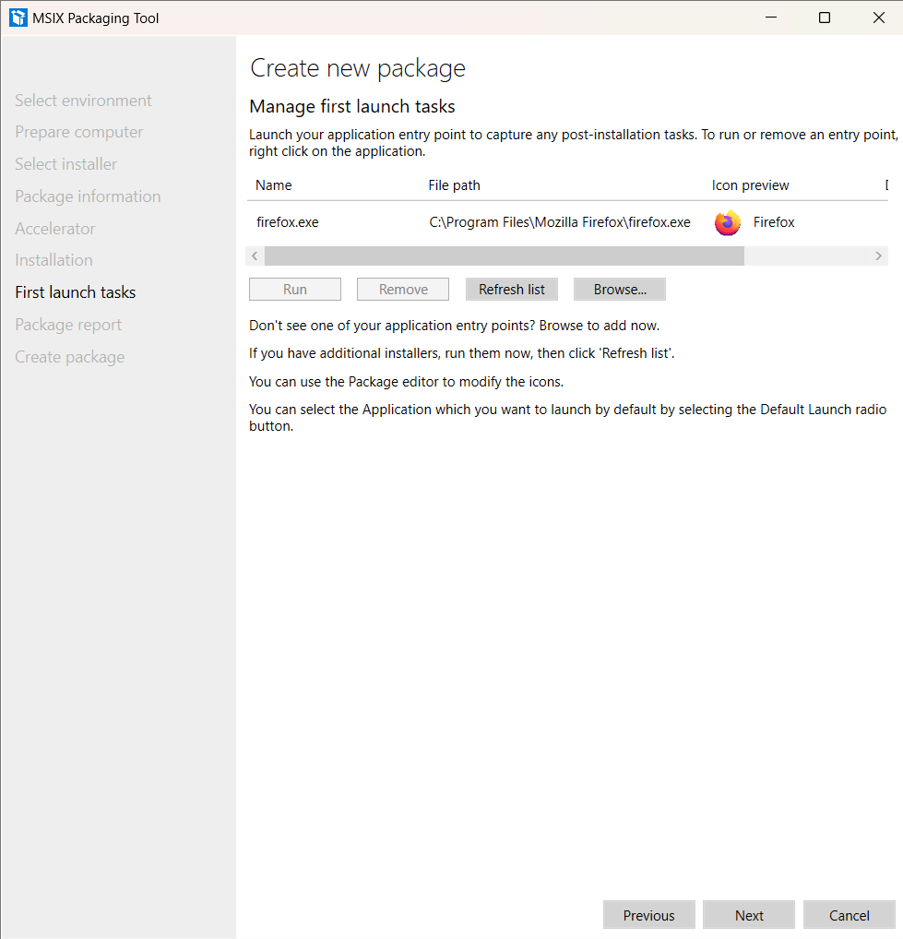

* Click on Yes, move on box

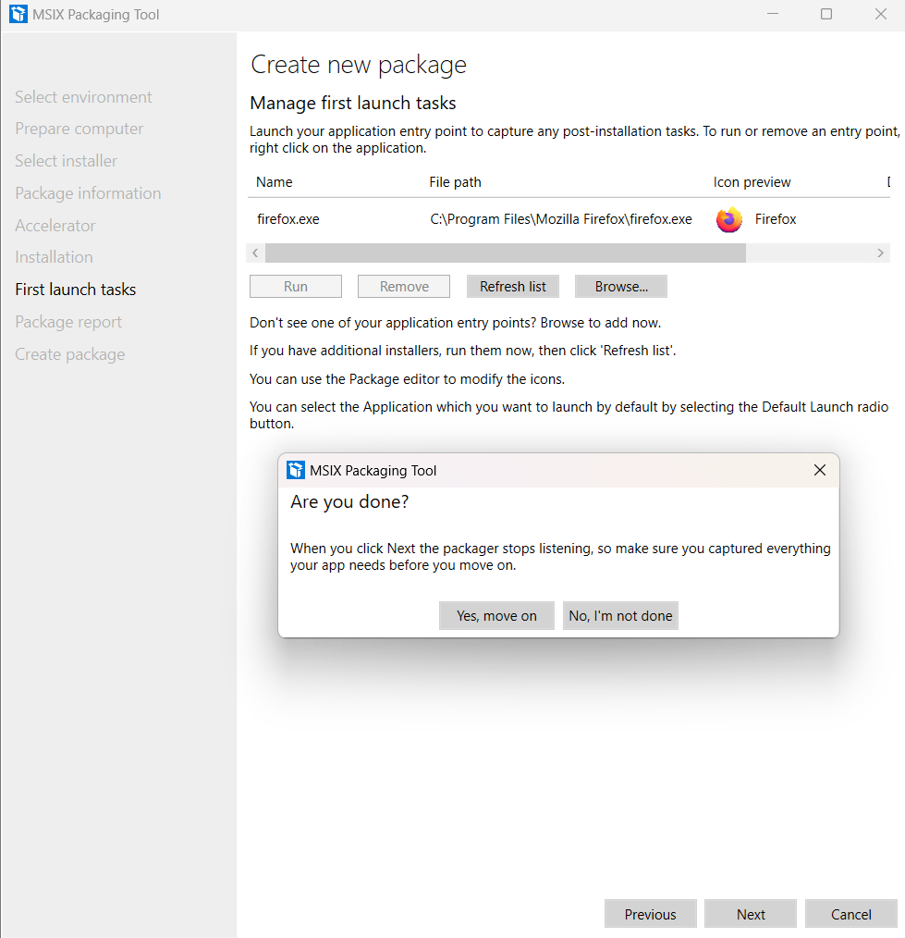

10)In tab, do click **Package report** tab, do nothing and click Next

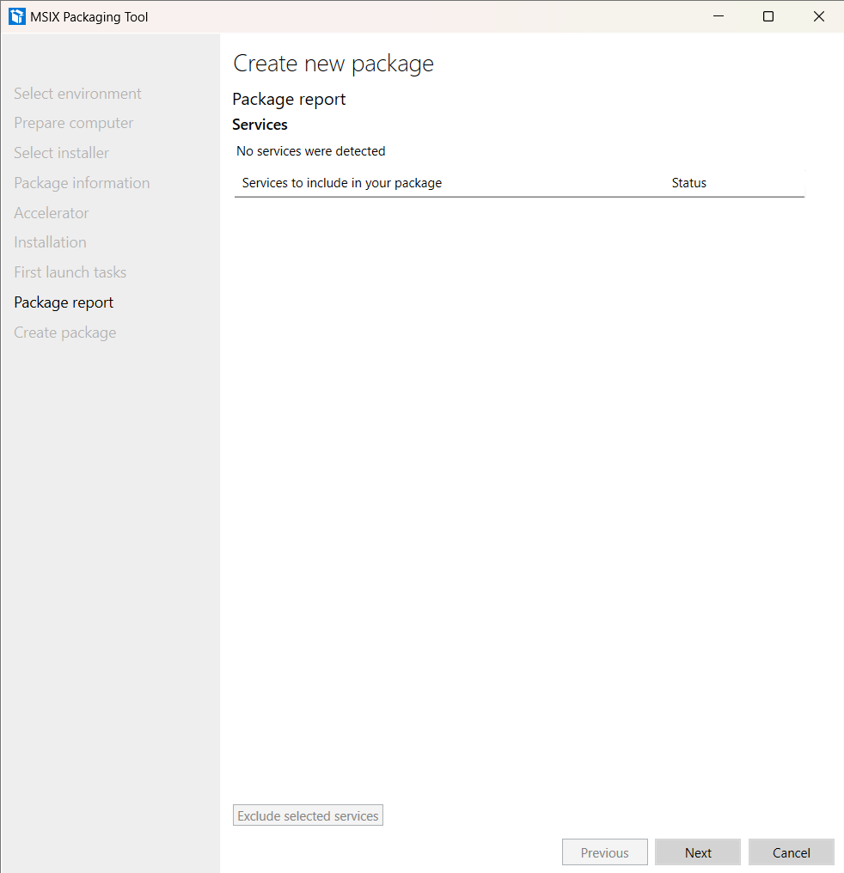

11)In **Create package** tab, browse the path where we want our Package and Files to be placed after getting created and click **Create** and then a small popup comes **Package successfully created** so click **Close** button

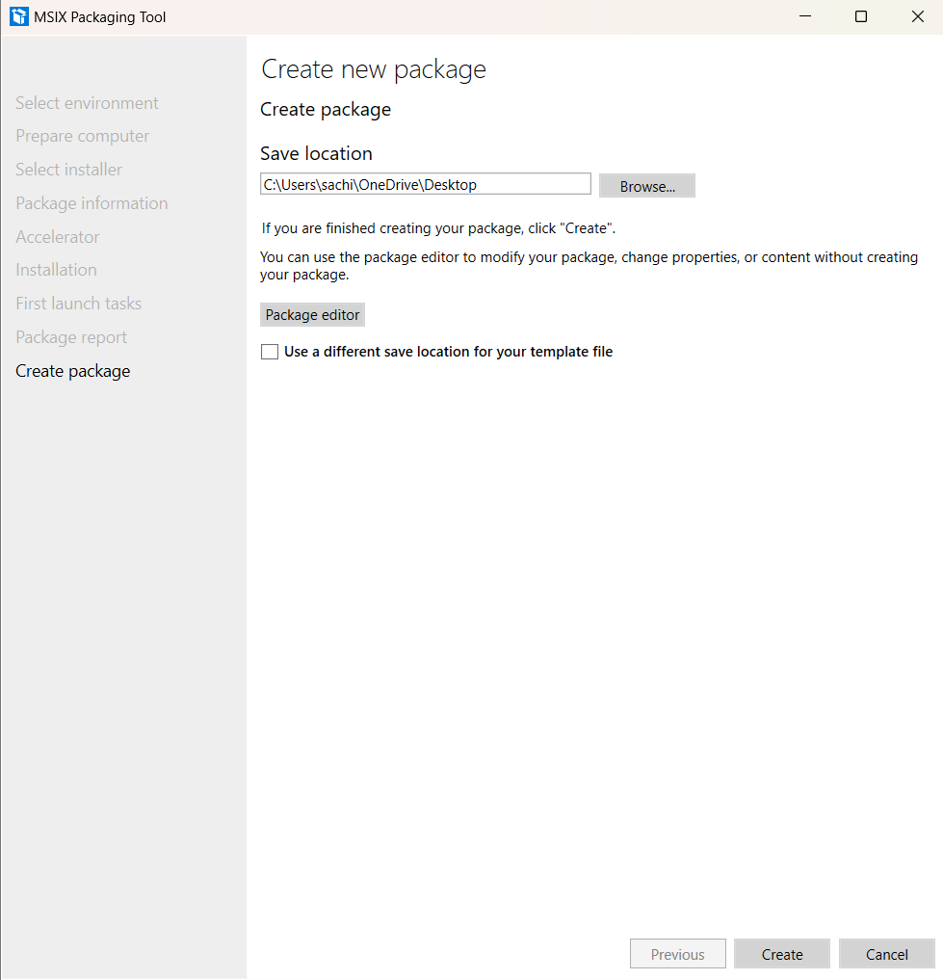

12)Open check for files in directory **File Explorer** and .**msix** and **.xml** our preferred

